6. To execute the following Nmap Timing and performance commands in Kali Linux operating Systems.

(i) paranoid IDS evasion

(ii) sneaky IDS evasion

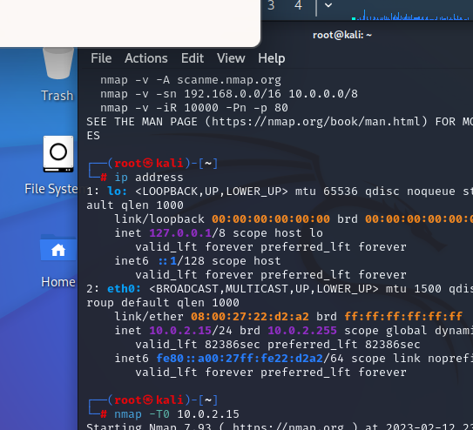

1. To cracking the password using any one of the tool in Kali linux operating systems.

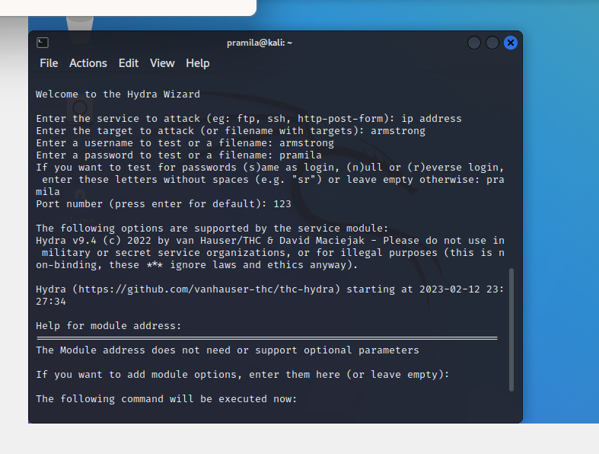

1. Using theHarvester to gather information about the domain "[www.saveetha.com](http://www.saveetha.com)", with a limit of 300 results, using all available data sources (the "-b all" flag), and to export the results in two formats: HTML and XML files. The result will be saved in the current working directory and will be named "test".

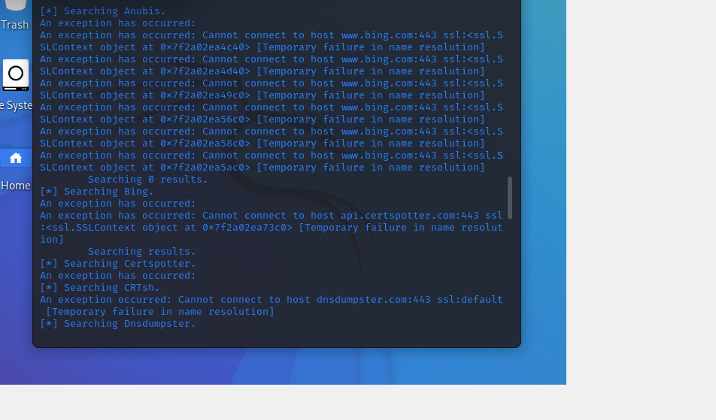

4.To execute the following commands in Kali Linux Operating Systems.

Pwd Command

Wget command

Touch command

